**APHASIABANK GESTURE AND DISCOURSE STUDY**

**PROTOCOLS AND BEST PRACTICES MANUAL**

IRB #14633 - Test-retest evaluation of spoken discourse and gesture in speakers with aphasia

**Contents**

Preassessment/Recruiting Procedures

* Recruitment
* Email Templates
* Participant Inclusion Parameters
* Scheduling with REDCap

Assessment Procedures

* Procedure for Aphasic Group
  + Day 1 Procedure
  + Day 2 Procedure
* Procedure for Control Group
  + Day 1 Procedure
  + Day 2 Procedure

Post Assessment Procedures

* Data Upload Protocol

Resources

# Recruitment

Recruitment will be completed virtually via emailing previous study participants and reaching out to aphasia/stroke support groups.

* List of known contacts (via Test Retest Ashfoundation study) from 2020 but will be updated as more sources develop --> <https://indiana.sharepoint.com/:x:/r/sites/msteams_0965a7/_layouts/15/Doc.aspx?sourcedoc=%7B0A4827D9-3079-40A3-B28D-79B1B1FD5E95%7D&file=RecruitmentContacts.xlsx&action=default&mobileredirect=true>

**Steps to contact participants:**

* Contact participant via preferred method as indicated in the prescreening survey.
* Schedule both test and retest appointments simultaneously.
* Make sure confirmation emails (immediately) and reminder emails (1 day before each session) are scheduled to be sent at the appropriate time and contain the following information:
  + The time and date of both sessions in the appropriate time zone
  + Virtual meeting link.
  + Instructions to download virtual meeting software
  + Materials needed
    - reliable Internet
    - headphones (if needed)
    - Laptop or desktop computer (not iPad)
    - Pen, book, and comb (for WAB Sequential Commands task) [Aphasic participants only]
  + Attached documents such as Informed Consent sheet and the Ideal Environment Checklist

# Email Templates

**Return Email to Interested Participant**

**Aphasic Group**

Hello ___,

Thank you so much for your interest in participating in our research to learn more about aphasia! My name is Grace Oeding, I work in the Neural Research Lab at Indiana University and I will be completing the research sessions with you. We will be looking at storytelling and gestures in people with aphasia across two sessions, a test and a retest.

Eligible participants will fit the following criteria:

1. Fluent English speaker (can speak other languages)
2. Diagnosis of aphasia after any brain injury, which you have had for at least six months
3. Able to see and hear well enough to participate in an online study
4. 18-85 years old.
5. No concurrent neurological disorder or progressive neurodegenerative disease

Participation in this study is voluntary, paid, and non-invasive.

The study will involve 2 days of testing, **one week apart**, with each day consisting of a morning and an afternoon session (**4 sessions altogether**). All testing will take place over Zoom. You will be compensated in the form of a $250 online Amazon gift card.

If you are interested, **please complete the survey linked below. We are currently scheduling sessions for the month of [Month].**Please let me know what days of the week and times are best for you!

**Pre-Screening Survey:**[**https://redcap.uits.iu.edu/surveys/?s=9ACPHWK3KHKEJ39M**](https://redcap.uits.iu.edu/surveys/?s=9ACPHWK3KHKEJ39M)

If you have any questions do not hesitate to ask!

Thank you,

Grace Oeding

*To insert prescreening survey link. Go to Survey Distribution Tools on Redcap. Make sure the survey link below applies only to **“Pre Screening- Pretest Arm 1 Aphasia”** and copy the survey link URL. This link can be sent to anyone and once the survey is complete, a new Study ID will be created.

**Control Group**

Hello!

My name is Grace Oeding, and I work in Indiana University’s Neural Research Laboratory. I hope this email finds you well! I am reaching out because you expressed interest in participating in our study. We will be looking at storytelling and gestures across two sessions, a test and a retest. Eligible participants will fit the following criteria:

• Fluent English speaker (can speak other languages)

• No history of brain injury or other neurological disorder

• 30-85 years of age

• Able to see and hear well enough to participate in an online study

Participation in this study is voluntary, paid, and non-invasive. The study will consist of two sessions spaced approximately 5-10 days apart. At this time, we are gauging interest and will begin scheduling in [Month], however, if you would like to fill out our prescreening survey, I have attached the link below!

[survey-link]

If you have any questions or are interested in participating.

Thank you,

Grace Oeding

**Scheduling Participants**

Hello,

Thank you so much for your interest in our study! Because our study requires two sessions, a test and a retest, we will need to schedule both times simultaneously. Both days will include 1 testing session in the morning that should last 1-2hours.

I am contacting you today to schedule those sessions. The following times and dates are available:

[insert dates and times]

Please let me know what works best for you! Once we confirm the date, I will make sure you will receive a reminder email or text before each session.

Thank you,

Grace Oeding

**Confirmation/ Reminder Email**

Hello!

This is a reminder that we have a session tomorrow, _____________. Please see the Zoom information below and let me know if you have any questions or difficulties joining the meeting!

Include Zoom information.

Here is some important information to know before joining the meeting:

* Please use a desktop or laptop computer, not a tablet or iPad.
* Please bring a pen, book, and comb to the session, you will need them for one of the tests we will be completing. [For aphasic participants]
* We will be looking at your gestures in this study so please be ready to position the camera to see your full upper body/hands while you speak.

Thank you,

Grace

# Inclusion Parameters

* **Aphasia:** 
  + We will recruit between the ages of 18 - 85 years old, though we anticipate most participants (due to the typical age of stroke in the USA) will be 40 - 75 years.
  + The inclusion parameters are:

1. have had a diagnosis of aphasia >6 months after a brain injury, like a stroke;
2. hearing (aided or unaided) adequate for testing based on clinical judgment or self-report;
3. vision (aided or unaided) adequate for testing based on clinical judgment or self-report;
4. fluent speakers of English;
5. no history of cognitively deteriorating conditions such as Alzheimer’s or Parkinson’s disease based on self-report

* **Neurotypical:** 
  + We will recruit between the ages of 30 - 85 years old.
  + The inclusion parameters are:

1. no neurological condition (e.g., stroke, head injury);
2. hearing (aided or unaided) adequate for testing based on clinical judgment or self-report;
3. vision (aided or unaided) adequate for testing based on clinical judgment or self-report;
4. fluent speakers of English;
5. no history of cognitively deteriorating conditions such as Alzheimer’s or Parkinson’s disease based on self-report; and

# Scheduling with Redcap

(<https://redcap.vanderbilt.edu/consortium/videoplayer.php?video=scheduling02.mp4&referer=redcap.uits.iu.edu&title=Scheduling>)

* Navigate to the scheduling tab under data collection
* Choose Create New Schedule and enter Study ID
* Generate schedule
* After entering times and confirming the correct time between days for Aphasia vs Control participants, choose Create Schedule
* You can find scheduled events in the Calendar tab under Applications

To sync the Redcap calendar to a Google calendar:

* In Redcap, select “Sync calendar to external application”
* Copy the link under “Live calendar feed: Add calendar from URL/Internet”
* Open google calendar
* Click the plus sign next to “Other calendars” on the bottom left of the page
* Select “From URL” and paste the link copied from Redcap

# Opening Survey Links on Redcap (to be used during testing)

* After navigating to Record Status Dashboard, choose the Study ID of the participant you are testing
* Select the survey you wish to open
* At the top right, select the drop-down menu called “Survey Options” and select Open Survey
* From here you can give remote control to the participant if they will be filling out the survey themselves

# Assessment Materials

## Study Materials for Aphasic Group

Day 1 AM:

* Informed Consent PWA
* Redcap Surveys (Informed Consent, Intake Form, PHQ 9)
* WAB-R Q-global Remote-Adapted Stimulus Book

To access standardized assessments, log-in to qglobal via the link below

* + [Q-global Sign In (pearsonclinical.com)](https://qglobal.pearsonclinical.com/qg/login.seam)
* [WAB Record Form](https://indiana.sharepoint.com/sites/msteams_0965a7/Shared%20Documents/Forms/AllItems.aspx?id=%2Fsites%2Fmsteams%5F0965a7%2FShared%20Documents%2FGeneral%2F%5BBox%20Health%5D%20Research%20Labs%2F%5BBox%20Health%5D%20Neural%20Research%20Lab%2FAPHASIABANK%20GESTURE%20%26%20DISCOURSE%20STUDY%2FAdminDocs%2FTesting%20Materials%2FWAB%20Record%20Form%20%2Epdf&parent=%2Fsites%2Fmsteams%5F0965a7%2FShared%20Documents%2FGeneral%2F%5BBox%20Health%5D%20Research%20Labs%2F%5BBox%20Health%5D%20Neural%20Research%20Lab%2FAPHASIABANK%20GESTURE%20%26%20DISCOURSE%20STUDY%2FAdminDocs%2FTesting%20Materials)
* TULIA Instructions

Day 1 PM:

* Discourse Script
* [Aphasiabank Picture Description Task](https://aphasia.talkbank.org/protocol/english/participant/index.html)
* [Cinderella Story](https://aphasia.talkbank.org/protocol/english/participant/sequences/Cinderella/index.html)

Day 2 AM:

* [TALSA Battery](https://talsapilot.org/)

Digit/Word Span à Word Span – Pointing or Digit Span Pointing

* [PNT](https://indiana.sharepoint.com/:p:/r/sites/msteams_0965a7/_layouts/15/Doc.aspx?sourcedoc=%7B49546620-D554-4A2D-B10E-AD7E736A430B%7D&file=S-PNT-A.ppt&action=edit&mobileredirect=true)
* [VNT](https://indiana.sharepoint.com/sites/msteams_0965a7/Shared%20Documents/Forms/AllItems.aspx?id=%2Fsites%2Fmsteams%5F0965a7%2FShared%20Documents%2FGeneral%2F%5BBox%20Health%5D%20Research%20Labs%2F%5BBox%20Health%5D%20Neural%20Research%20Lab%2FAPHASIABANK%20GESTURE%20%26%20DISCOURSE%20STUDY%2FAdminDocs%2FTesting%20Materials%2Fvnt%2Dfull%2Epdf&viewid=5bb9006e%2Da4f6%2D4b2b%2Da0b8%2D432a10309e83&parent=%2Fsites%2Fmsteams%5F0965a7%2FShared%20Documents%2FGeneral%2F%5BBox%20Health%5D%20Research%20Labs%2F%5BBox%20Health%5D%20Neural%20Research%20Lab%2FAPHASIABANK%20GESTURE%20%26%20DISCOURSE%20STUDY%2FAdminDocs%2FTesting%20Materials)
* [Concrete Abstract Picture Description Task](https://indiana.sharepoint.com/:p:/r/sites/msteams_0965a7/_layouts/15/Doc.aspx?sourcedoc=%7B17E091E8-83F0-46AC-88D7-AD2F4F0CFFBB%7D&file=Gesture_ConcreteAbstract.pptx&action=edit&mobileredirect=true)
* [Address Task](https://indiana.sharepoint.com/:p:/r/sites/msteams_0965a7/Shared%20Documents/General/%5BBox%20Health%5D%20Research%20Labs/%5BBox%20Health%5D%20Neural%20Research%20Lab/APHASIABANK%20GESTURE%20%26%20DISCOURSE%20STUDY/AdminDocs/Project%20Protocols/Address%20description%20task-.pptx?d=w67331d76140f45798cdba9d14503986d&csf=1&web=1&e=1GHT7b)

Day 2 PM:

* Discourse Script
* [Aphasiabank Picture Description Task](https://aphasia.talkbank.org/protocol/english/participant/index.html)
* [Cinderella Story](https://aphasia.talkbank.org/protocol/english/participant/sequences/Cinderella/index.html)

## Data Collection Procedures for Aphasic Group

**Testing will include 2 sessions- one session in the morning and one in the afternoon:**

Day 1 AM:

Approximately 2 hour long, will include the following tasks:

* Informed Consent and Demographic/Intake form (30 minutes)
* PHQ9 (5-10 minutes)
* Western Aphasia Battery (45 minutes)
* Limb Apraxia (10 minutes)

Day 1 PM:

* Aphasiabank Discourse battery

Day 2 AM:

* TALSA battery (50 minutes)
* Philadelphia Naming Test (30 minutes)
* Verb Naming Test (20 minutes)
* Concrete and abstract picture description task (30 minutes)

Day 2 PM:

* Repeat AphasiaBank Discourse battery

## Day 1 AM Procedure:

**Before Participant Arrives:**

* Begin Teams session and have all materials and instructions ready to go at least 15 minutes early.
* Confirm you have all the materials and instructions you need for each test.
* Perform Internet connection check:
  + Ethernet connection (preferred) or reliable Wi-Fi. If possible, confirm the reliability of your Internet by determining bandwidth and speed Hardware
* Screen sharing device (i.e., computer, iPad) with an adequate display resolution (roughly 9 in. of screen) is required
* Built-in or external webcam/camera device
* Functioning audio system is required (i.e., microphone, speaker)
* Headphones for investigator and participant are recommended
* Recommended that device can stand on its own (i.e., not required to be handheld)
* Make sure your own experimental environment is ideal before participant arrives:
* Close household windows to reduce background noise
* Notify other people that you are in a session
* Remove pets from the room (if possible)
* Turn phone and other devices to silent or off
* Close door(s) to room (if possible)
* Close all unnecessary programs and windows on computer

**Equipment Check**

**“Hello! Before we start today, let’s make sure that our equipment and surroundings are in good shape.”**

**“Can you hear me?”**

*If no reply, make sure your microphone and their microphone is not muted.*

*If you are not muted, send first statement in chat. Wait for 30 seconds and try again.*

*If yes, say:* “Okay, great. Now let’s test your microphone. Say a few sentences.”

*If you can’t hear them clearly, ask them to speak more directly into the microphone and try again.*

*Once the sound check is complete, say:* **“Now that we can both hear each other clearly, let’s quickly check video feeds. Can you see me?”**

*If not, trouble shoot the problem.*

*If yes, and you cannot see the participant, make sure they have their video feed unmuted.*

*If yes, and you can see the participant, move on.*

**“Last thing to check is to make sure we are both in quiet environments without distractions. Let’s go through the checklist together.”**

**Go through the entire Environment Check checklist located below:**

Environment and experiment setup

1. Image (i.e., camera placement) of participant and investigator should include head and shoulders in the center of the screen
2. If necessary, the camera angle should be adjusted to include participant gesticulation
3. Lighting should be adequate for clear visibility (i.e., facial features, object manipulation)
4. Make sure camera is able to see full upper body including any space where gesturing may occur.

To prevent potential distractions from the experimental environment:

1. Close household windows to reduce background noise
2. Notify other people that you are in a session
3. Remove pets from the room (if possible)
4. Turn phone and other devices to silent or off
5. Close door(s) to room (if possible)
6. Close all unnecessary programs and windows on computer

**If these conditions are not met, ask participant to adjust their chair, computer positioning, or body angle until their full upper body is in view with no obstructions so that ALL gestures are able to be seen.**

**Confirm Recording Now and Make Sure Participant is Pinned**

**Rename participant on zoom to ID number**

**Do NOT Proceed Until The Session Is Recording!**

* To confirm that the recording is going to download to your computer, make sure that you see Pause/Stop Recording buttons on the bottom control bar.

**Informed Consent**

Open [Informed Consent_PWA](https://indiana.sharepoint.com/:p:/r/sites/msteams_0965a7/_layouts/15/Doc.aspx?sourcedoc=%7BDE8D61D7-64C7-49EC-AFC4-765BBE09C64C%7D&file=Informed%20Consent_PWA%20(1).pptx&action=edit&mobileredirect=true) and share screen with participant.

**“Hello [*potential participant name*], I am Grace Oeding from Indiana University Bloomington and the NEURAL Research Lab. This study is being run by Dr. Brielle Stark, who is reachable by phone (812-855-7760) or email (**[**bcstark@iu.edu**](mailto:bcstark@iu.edu)**).**

**We are investigating how things involving language, like storytelling, are similar across testing sessions. This will help us tailor assessment and treatment of disorders such as aphasia, which is a language disorder acquired after a brain injury to the left hemisphere. During this study, we will audio-video record your responses to some cognitive and language assessments. Should you choose to participate, there are two sessions included in this research, which will take place roughly 10 +/- 3 days apart. Each session will consist of two parts: one in the morning and one in the afternoon. Your confidentiality will be protected to the best of our ability by using a HIPAA-compliant virtual meeting system (Zoom Health) and saving all videos and protected health information to our HIPAA-compliant cloud server system (Box Health) and database (REDCap). In enrolling in this study, your data will be assigned to a unique, anonymous identifier number, rather than your name. Your participation is voluntary and you may choose to stop participating at any time.**

**If you have any questions, please feel free to ask now. [*participant asks questions*]”**

Open the Informed Consent survey on Redcap and either share link with participant, or share your screen to complete the survey together.

**Intake Form**

**“Now we will complete an online intake form. The server is secure, and I can read the questions to you if you want. This information will help us know more about you!”**

Open the Intake Form survey on Redcap and either share link with participant or share your screen to complete the survey together.

**PHQ 9 Depression Questionnaire**

**“For the last online survey, you will be asked a few questions about how you’ve been feeling over the last two weeks.” Explain answer choices (Not at all, several days, etc.)**

Open the PHQ 9 survey on Redcap and either share link with participant or share your screen to complete the survey together.

**Western Aphasia Battery**

*Before administering the WAB, familiarize yourself with* [*the Examiner’s Manual*](https://qglobal.pearsonassessments.com/qg/viewRestrictedPdfS.seam) *and Record Form.*

Materials:

* WAB Remote-Adapted Stimulus (digital)
* WAB Record Form (print)
* [telepractice and the WAB](https://www.pearsonassessments.com/content/dam/school/global/clinical/us/assets/telepractice/guidance-documents/telepractice-and-the-wab-r.pdf) guidelines

**Follow instructions and dialogue listed on the WAB Part 1 Record Form. This form also includes scoring instructions.**

**Test of Upper-Limb Apraxia**

**Materials:**

* Apraxia Screen of TULIA (print or digital)
  + [**https://www.sralab.org/sites/default/files/2017-07/apraxia_screen_of_tulia_ast.pdf**](https://www.sralab.org/sites/default/files/2017-07/apraxia_screen_of_tulia_ast.pdf)
* Follow the instructions featured in the pdf

**“The first part of the session is now complete. We will now take a [*insert break time*] and reconvene at [*insert time*] to resume testing.”**

## Day 1 PM Procedure:

**Dialogue Speech Samples**

Converse with the participant about one of the following subjects for *at least* two minutes:

1. **The best trip you ever took**
2. **Your favorite holiday as a child**
3. **Your worst childhood memory**
4. **When you retired**
5. **The worst trip you ever took**
6. **A happy childhood memory**
7. **When you had your first child**
8. **What you like about where you live**
9. **When you got married**
10. **Your first job**
11. **How you met your husband/wife/partner**
12. **A time you were really scared/embarrassed/angry**

**AphasiaBank Protocol**

**Materials:**

* Protocol Manual Script (print)

Instructions:

* Allow ample time for as full a response as each participant can provide using this protocol script.
* For those unable to respond to any of the prompts for the Stroke Story, skip the Important Event task and proceed to the first Picture Description (Broken Window).
* If the participant responds to the Broken Window picture description prompt, continue with the protocol, changing the order if that helps, and returning to the initial questions if appropriate.
* If the participant does not respond to the Broken Window picture, and you believe these tasks are too difficult, you can discontinue as you see fit.
* To facilitate transcription, the examiner's speech, including verbal encouragers, should be kept to a minimum.
* Use nonverbal encouragers (e.g., head nods, facial expressions, eye contact) instead of verbal encouragers (e.g., “I see”, “mhm”, “yeah”) whenever possible.

**Section 1: Free Speech Samples**

Start with a preliminary unrecorded conversation for social exchanges, signing consent forms, explaining about recording the session, answering any questions, and so forth.

**BEGIN RECORDING**

If your institution requires it, record the following preamble about informed consent, then lead into the first recorded protocol item (Stroke Story). If not, go straight to the Stroke Story.

Investigator:

**"This participant has signed an informed consent form. These data can be used for ______________ (specify: research, teaching, or any purpose). These data are not to be used for ____________ (specify any restrictions)."**

**A. STROKE STORY and COPING**

**1.** **“I’m going to be asking you to do some talking. How do you think your speech is these days?”**

If no response in approximately 10 seconds, prompt:

**“How's your talking?”**

Listen, encourage full response. If no response, prompt:

**“Are you having trouble with your talking?”**

**2. “Do you remember when you had your stroke?”**

If yes, **“Please tell me about it.”**

If no, “**Well, how about your first memories after the stroke. What can you tell me about that?”**

If no response in approximately 10 seconds, prompt:

**“Try to tell me about the day you had your stroke.”**

Listen, encourage full response. If no response, prompt:

**“Do you remember your stroke?”**

At a natural juncture add:

**3.** **"Tell me about your recovery. What kinds of things have you done to try to get better since your stroke?"**

If no response in approximately 10 seconds, prompt:

**“Tell me about any changes you’ve needed to make in your daily life.”**

If no response, prompt: **“Did you have any therapy after your stroke?”**

**“Now I’m going to ask you to do a few more things where you need to talk. Please talk as much as you can about each one, because we’re really interested in knowing about your language."**

**B. IMPORTANT EVENT**

**“Thinking back, can you tell me a story about something important that happened to you in your life? It could be happy or sad or from any time --from when you were a kid or more recently."**

If no response in approximately 10 seconds, prompt:

**"For instance, you could tell me about a trip you took or something about your family or your work --anything."**

If no response, go on to Picture Descriptions.

**Section 2: Picture Descriptions**

**A. BROKEN WINDOW**

**“Now I’m going to show you these pictures."**

Present picture series.

**“Take a little time to look at these pictures. They tell a story. Take a look at all of them, and then I’ll ask you to tell me the story with a beginning, a middle, and an end. You can look at the pictures as you tell the story”**

If no response in 10 seconds, give second prompt:

**“Take a look at this picture (point to first picture) and tell me what you think is happening.”**

If needed, point to each picture sequentially, giving the prompt:

**“And what happens here?”**

For each panel, if no response, provide the prompt:

**“Can you tell me anything about this picture?”**

If no response at all, prompt:

**“Is the boy kicking the ball through the window?”**

**4B. REFUSED UMBRELLA**

Present picture series.

**“Here are some more pictures that tell a story. Take a look at all of them, and then I’ll ask you to tell me the story with a beginning, a middle, and an end. Again, you can look at the pictures as you tell the story.”**

If no response in 10 seconds, give second prompt:

**“Look at this picture (point to first panel) and tell me what you think is happening.”**

If needed, point to each panel sequentially, giving the prompt:

**“And what happens here?”**

For each panel, if no response, provide the prompt:

**“Can you tell me anything about this picture?”**

If no response at all, prompt:

**“Did the boy refuse the umbrella?”**

**C. CAT RESCUE**

Present picture.

**“Here is another picture. Look at everything that’s happening and then tell me a story about what you see. Tell me the story with a beginning, a middle, and an end.”**

If no response in 10 seconds, give second prompt:

**“Take a look (point to picture) and tell me any part of the story.”**

If fewer than 2 utterances, give third prompt:

**“Anything else you can tell me about the story?”**

If no response at all, prompt:

**“Is the cat stuck in the tree?”**

**Section 3: Story Narrative**

**CINDERELLA**

Open link for Cinderella story: <https://aphasia.talkbank.org/protocol/english/participant/sequences/Cinderella/index.html>

**“I’m going to ask you to tell a story. Have you ever heard the story of Cinderella?”**

(Make note of answer for demographic data. If answer is no, ask participant to tell a fairy tale s/he knows.)

**“Do you remember much about it? These pictures might remind you of how it goes. Take a look at the pictures, and then I’ll close the page and ask you to tell me the story in your own words.”**

Allow participant to look through book (assist with page turning if needed), and then prompt:

**“Now tell me as much of the story of Cinderella as you can. You can use any details you know about the story, as well as the pictures you just looked at.”**

If participant gives a response of fewer than three utterances, or seems to falter, allow 10 seconds, then prompt:

**“What happened next?”**

or

**“Go on.”**

Continue until participant concludes story or has clearly finished.

If no response, prompt:

**“Did Cinderella go to the ball and meet the prince?”**

**Neutral Cue Storytelling**

**Now I am going to ask you to tell a few stories from your personal life. First, I will give you a word and you will construct a story from your real life that relates to or involves the word given.**

Read each word below and encourage the participant to talk in complete sentences. If participant only gives a few utterances or cannot think of an event from their real life, ask them to imagine a story involving the word given.

* **clock**
* **bird**
* **hotel**
* **restaurant**

**Section 4: Procedural Discourse**

**PEANUT BUTTER AND JELLY SANDWICH**

Do not use a picture stimulus for this task.

**“Let’s move on to something a little different. Tell me how you would make a peanut butter and jelly sandwich.”**

If no response in 10 seconds, give second prompt:

**“If you were feeling hungry for a peanut butter and jelly sandwich, how would you make it?”**

If no response, prompt:

**"Do you like eating peanut butter and jelly sandwiches?"**

**PROCEDURAL 2- LAUNDRY**

Do not use a picture stimulus for this task.

**“Now explain to me how you do your laundry.”**

If no response in 10 seconds, give second prompt:

**“If you had dirty clothes, how would you do your laundry?”**

If no response, prompt:

**“Have you ever done laundry before?”**

**PROCEDURAL 3 (TEST ONLY)- GETTING DRESSED IN THE MORNING**

Do not use a picture stimulus for this task.

**“How would you get dressed in the morning on a normal weekday?”**

## Day 2 AM Procedure:

**TALSA BATTERY**

**Materials**

* TALSA Battery website ready to be shared with participant
  + <https://talsapilot.org/>

**Instructions**

* Open TALSA Battery website and navigate to Word Span-Pointing under Short Term Memory Tests --> Digit//Word Span
* Ensure sound is shared
* When test is ready to begin, give remote control to participant.
* Save the excel score sheet immediately after testing
* Repeat this process for Digit Span-Pointing

**Scoring**

-TALSA Score Sheet

**Philadelphia Naming Test**

**Materials**

* PNT PowerPoint (available digitally and printed)

Have printed copy for yourself and the PowerPoint ready to be shared on screen

**Instructions to Subject:**

**“I'm going to ask you to name some pictures. A picture will appear on the computer screen. Your job is to name the picture using only one word.”**

<https://indiana.sharepoint.com/:p:/r/sites/msteams_0965a7/_layouts/15/Doc.aspx?sourcedoc=%7B49546620-D554-4A2D-B10E-AD7E736A430B%7D&file=S-PNT-A.ppt&action=edit&mobileredirect=true>

After the subject has finished responding to an item, give him/her feedback: e.g.., "good, that's a fish", or “actually, they're looking for garage here”, or some variation thereof. Allow a maximum of 30 seconds for the subject's response.

**Verb Naming Test**

**Materials**

1. VNT PowerPoint (available digitally and printed)
   1. Have printed copy for yourself and the PowerPoint ready to be shared on screen
2. [**https://indiana.sharepoint.com/sites/msteams_0965a7/Shared%20Documents/General/%5BBox%20Health%5D%20Research%20Labs/%5BBox%20Health%5D%20Neural%20Research%20Lab/APHASIABANK%20GESTURE%20&%20DISCOURSE%20STUDY/AdminDocs/Testing%20Materials/VNT.pdf**](https://indiana.sharepoint.com/sites/msteams_0965a7/Shared%20Documents/General/%5BBox%20Health%5D%20Research%20Labs/%5BBox%20Health%5D%20Neural%20Research%20Lab/APHASIABANK%20GESTURE%20&%20DISCOURSE%20STUDY/AdminDocs/Testing%20Materials/VNT.pdf)
3. Follow administration and scoring instructions featured in the pdf

**Concrete and Abstract Picture Description Task**

**Materials**

* Gesture_ConcreteAbstract” PowerPoint
* <https://indiana.sharepoint.com/:p:/r/sites/msteams_0965a7/_layouts/15/Doc.aspx?sourcedoc=%7B17E091E8-83F0-46AC-88D7-AD2F4F0CFFBB%7D&file=Gesture_ConcreteAbstract.pptx&action=edit&mobileredirect=true>

**Instructions**

Task1: Abstract vs. concrete images

* *Aim:* To examine how individuals with aphasia and aged-match controls use gesture to describe **abstract vs concrete images.**

**After sharing your screen, instruct participants to describe each image they see.**

“For this task, I am going to show you some pictures. Please describe the images you see as soon as you see it. Feel free to use gestures or any method to help you describe the images.”

**After the concrete images, present the abstract images. Ask the participant to describe each image they see.**

“These next images will look different. Again, please try your best to describe the images you see.”

Task2: Address description task

* *Aim:* To examine how individuals with aphasia and aged-match controls use gesture to describe **how to get from one point to another:** Home, grocery store, family/friend home to their own home

1.“Can you describe the path you take to get from home to your grocery store”

2.“Tell me how to get from a friend/relative’s home back to your home”

If confused or no response, some probing questions like:

* Do you have any relatives or friends that live nearby?
* Do you see any relatives or friends frequently?
* Do you often drive there, or do you use a bus?

Can you describe to me how you might get to that place from your home as if I wanted to drive from your house to theirs?

Example:

For example, I often travel to my friend Josh's house. To get there, I get in my car, turn onto my street, and then drive east to the nearby highway. Once I'm on the highway, I go about three miles. I turn left onto Josh's road. It takes me about 2 minutes on that road to get to his house.

3.“Can you describe the path you took to get from your home to your work”.

4.“Can you describe the path you take to get from your home to your local gas station”

## Day 2 PM Procedure:

**Dialogue Speech Samples**

Converse with the participant about one of the following subjects for *at least* two minutes:

If one topic does not provide two minutes of conversation you may need to discuss more than one topic.

*Do not discuss the same topics as from test session.

1. **The best trip you ever took**
2. **Your favorite holiday as a child**
3. **Your worst childhood memory**
4. **When you retired**
5. **The worst trip you ever took**
6. **A happy childhood memory**
7. **When you had your first child**
8. **What you like about where you live**
9. **When you got married**
10. **Your first job**
11. **How you met your husband/wife/partner**
12. **A time you were really scared/embarrassed/angry**

[Repetition of AphasiaBank discourse tasks featured in Day1pm]

#### SECTION IV: PROCEDURAL DISCOURSE

The last question of Procedure Discourse is different from Day1pm. See below.

**PROCEDURAL 4 (RETEST ONLY)- GROWING A FLOWER**

Do not use a picture for this task

**“Now explain how you would grow a flower in a garden or pot.”**

If no response in 10 seconds, prompt:

**“If you had to plant a flower, how would you make sure it grows?”**

# **Data Collection for Control Group**

**Testing will include 2 sessions:**

**Session 1**

1. Informed consent and intake procedure
2. PHQ9 (5-10 minutes)
3. MOCA (10-15 minutes)
4. LEAP-Q (If bilingual)
5. Discourse battery (45-60 minutes)

**Session 2**

1. WAIS IV
   1. Digit span
   2. Arithmetic
   3. Letter number sequencing
2. Concrete and abstract picture description task
3. Address Description Task
4. Repeat discourse battery

## ***Day 1 Procedure:***

Before Participant Arrives:

* Begin Teams session and have all materials and instructions ready to go at least 15 minutes early.
* Perform Internet connection check:
  + Ethernet connection (preferred) or reliable Wi-Fi. If possible, confirm the reliability of your Internet by determining bandwidth and speed Hardware
* Screen sharing device (i.e., computer, iPad) with an adequate display resolution (roughly 9 in. of screen) is required
* Built-in or external webcam/camera device
* Functioning audio system is required (i.e., microphone, speaker)
* Headphones for investigator and participant are recommended
* Recommended that device can stand on its own (i.e., not required to be handheld)
* Make sure your own experimental environment is ideal before participant arrives:
  + Close household windows to reduce background noise
  + Notify other people that you are in a session
  + Remove pets from the room (if possible)
  + Turn phone and other devices to silent or off
  + Close door(s) to room (if possible)
  + Close all unnecessary programs and windows on computer

### ***Equipment Check:***

**“Hello! Before we start today, let’s make sure that our equipment and surroundings are in good shape.”**

**“Can you hear me?”**

*If no reply, make sure your microphone and their microphone is not muted.*

*If you are not muted, send first statement in chat. Wait for 30 seconds and try again.*

*If yes, say:* “Okay, great. Now let’s test your microphone. Say a few sentences.”

*If you can’t hear them clearly, ask them to speak more directly into the microphone and try again.*

*Once the sound check is complete, say:* **“Now that we can both hear each other clearly, let’s quickly check video feeds. Can you see me?”**

*If not, trouble shoot the problem.*

*If yes, and you cannot see the participant, make sure they have their video feed unmuted.*

*If yes, and you can see the participant, move on.*

**“Last thing to check is to make sure we are both in quiet environments without distractions. Let’s go through the checklist together.”**

**Go through the entire Environment Check checklist located below:**

Environment and experiment setup

* Image (i.e., camera placement) of participant and investigator should include head and shoulders in the center of the screen
* If necessary, the camera angle should be adjusted to include participant gesticulation
* Lighting should be adequate for clear visibility (i.e., facial features, object manipulation)
* Make sure camera is able to see full upper body including any space where gesturing may occur.

To prevent potential distractions from the experimental environment:

* Close household windows to reduce background noise
* Notify other people that you are in a session
* Remove pets from the room (if possible)
* Turn phone and other devices to silent or off
* Close door(s) to room (if possible)
* Close all unnecessary programs and windows on computer

**Confirm Recording Now. Do NOT Proceed Until The Session Is Recording!**

Make sure to pin participant

Rename to ID number

To confirm that the recording is going to download to your computer, make sure that you see Pause/Stop Recording buttons on the bottom control bar.

### ***Informed Consent***

“Hello [*potential participant name*], I am Grace Oeding from Indiana University Bloomington and the NEURAL Research Lab. This study is being run by Dr. Brielle Stark, who is reachable by phone (812-855-7760) or email ([bcstark@iu.edu](mailto:bcstark@iu.edu)).

We are investigating how things involving language, like storytelling, are similar across testing sessions. This will help us tailor assessment and treatment of disorders such as aphasia, which is a language disorder acquired after a brain injury to the left hemisphere. During this study, we will audio-video record your responses to some cognitive and language assessments. Should you choose to participate, there are two sessions included in this research, which will take place roughly 10 +/- 3 days apart. Your confidentiality will be protected to the best of our ability by using a HIPAA-compliant virtual meeting system (Zoom Health) and saving all videos and protected health information to our HIPAA-compliant cloud server system (Box Health) and database (REDCap). In enrolling in this study, your data will be assigned to a unique, anonymous identifier number, rather than your name. Your participation is voluntary, and you may choose to stop participating at any time.

If you have any questions, please feel free to ask now. [*participant asks questions*]

**"First, let's fill out some forms, I will share my screen and give you control to use your mouse to fill out the survey.”**

***Informed Consent***

**“The first form for today is the informed consent form. Please fill out the survey. At the end of the page, you will be asked if you consent to have your data kept on AphasiaBank. AphasiaBank is a database only accessible by researchers and clinicians that is utilized to look at language.”**

### ***Intake Form***

**“Now please proceed to second link and code, which is the online intake form. This information will help us know more about you.”**

**[Use this survey see if the participant answered YES for the bilingual question]**

### ***PHQ9***

**Instructions:**

**“I will now ask you to complete a survey privately. You will now select the third link and enter the code below. Please let me know when you’ve completed all the questions.”**

### ***LEAP-Q (ONLY COMPLETE IF THE PARTICIPANT IS BILINGUAL)***

**“I will now ask you to complete a survey privately. You will now select the third link and enter the code below. Please let me know when you’ve completed all the questions.”**

### ***MOCA Administration***

**via Audio-Visual Conference Instructions**

All instructions may be repeated once.

**Identify yourself, from which clinic/institution and in which city you are located.**

Tell the subject the purpose of your call, obtain their verbal consent to proceed and instruct them to get a white sheet of paper, a pencil and an eraser, and to isolate themselves in a quiet room. The rater shows the subject the visual section of the MoCA (first 8 points).

Follow the administration of the Audio-Visual Conference version of MoCA.

**Data Capture:**

**“Please hold your paper up in front of your face so I can take a picture of it.”**

TOTAL SCORE: Sum all subscores listed on the right-hand side. Add one point for subject who has 12 years or fewer of formal education, for a possible maximum of 30 points. A final total score of 26 and above is considered normal according to MoCA standards.

**“Now I will need a moment to score your results for the Montreal Cognitive Assessment”**

[STOP HERE AND SCORE THE MOCA]

If the participant receives a score of less than 23, you must discontinue the protocol and end the session. Say: **“Thank you for your patience and participation. Our study requires that participants receive a score of >23 and you received a score of ____. I want to assure you that your score is not a reflection of your intelligence or suggests severe cognitive impairment. The MoCA is simply a screening tool for mild cognitive impairment, which we use to ensure that all the participants meet a certain score on cognitive functioning. This unfortunately means that we cannot proceed with this study. Thank you for taking the time to participate in our study”.**

**Confirm Participant’s Hands are in View**

### ***Dialogue Speech Samples***

Converse with the participant about one of the following subjects for *at least* two minutes:

If one topic does not provide two minutes of conversation you may need to discuss more than one topic.

* **The best trip you ever took**
* **Your favorite holiday as a child**
* **Your worst childhood memory**
* **When you retired**
* **The worst trip you ever took**
* **A happy childhood memory**
* **When you had your first child**
* **What you like about where you live**
* **When you got married**
* **Your first job**
* **How you met your husband/wife/partner**
* **A time you were really scared/embarrassed/angry**

### ***AphasiaBank Protocol:***

Instructions:

* Allow ample time for as full a response as each participant can provide using this protocol script.
* For those unable to respond to any of the prompts for the Stroke Story, skip the Important Event task and proceed to the first Picture Description (Broken Window).
* If the participant responds to the Broken Window picture description prompt, continue with the protocol, changing the order if that helps, and returning to the initial questions if appropriate.
* If the participant does not respond to the Broken Window picture, and you believe these tasks are too difficult, you can discontinue as you see fit.
* To facilitate transcription, the examiner's speech, including verbal encouragers, should be kept to a minimum.
* Use nonverbal encouragers (e.g., head nods, facial expressions, eye contact) instead of verbal encouragers (e.g., “I see”, “mhm”, “yeah”) whenever possible.

#### Section 1: Free Speech Samples

Start with a preliminary unrecorded conversation for social exchanges, signing consent forms, explaining about recording the session, answering any questions, and so forth.

**BEGIN RECORDING**

If your institution requires it, record the following preamble about informed consent, then lead in to the first recorded protocol item (Stroke Story). If not, go straight to the Stroke Story.

Investigator:

**"This participant has signed an informed consent form. This allows data to be kept on Aphasiabank. I am going to ask you to do some talking. Please feel free to gesture in addition to your speech.”**

1. **ILLNESS STORY AND COPING**

Question 1: "In this research project, I ask people who've had strokes to tell me what they remember about when they had their stroke. Since you haven't had a stroke, I wonder if you could tell me what you remember about any illness or injury you've had.”

If no response in 10 seconds, prompt:

"Tell me about any time you’ve been sick or hurt."

At a natural juncture, add:

Question 2: "Tell me about your recovery from that illness (or injury). What kinds of things did you do to get better?"

If no response in 10 seconds, prompt:

"Tell me about any things you did to get well."

Question 3: "Have you had any experience with people who have a difficult time communicating?"

If yes, "Please tell me what the problems were and what you did about it."

If no, "Have you ever had trouble communicating with someone, like talking to people from another country?"

If no response in 10 seconds, prompt:

"Tell me about a time when you had trouble communicating with someone or someone had trouble communicating with you.”

**B. IMPORTANT EVENT**

**“Thinking back, can you tell me a story about something important that happened to you in your life? It could be happy or sad or from any time --from when you were a kid or more recently."**

If no response in approximately 10 seconds, prompt:

**"For instance, you could tell me about a trip you took or something about your family or your work --anything."**

If no response, go on to Picture Descriptions.

#### SECTION II: PICTURE DESCRIPTIONS

**A. BROKEN WINDOW**

**“Now I’m going to show you these pictures."**

Present picture series.

**“Take a little time to look at these pictures. They tell a story. Take a look at all of them, and then I’ll ask you to tell me the story with a beginning, a middle, and an end. You can look at the pictures as you tell the story”**

If no response in 10 seconds, give second prompt:

**“Take a look at this picture (point to first picture) and tell me what you think is happening.”**

If needed, point to each picture sequentially, giving the prompt:

**“And what happens here?”**

For each panel, if no response, provide the prompt:

**“Can you tell me anything about this picture?”**

If no response at all, prompt:

**“Is the boy kicking the ball through the window?”**

**4B. REFUSED UMBRELLA**

Present picture series.

**“Here are some more pictures that tell a story. Take a look at all of them, and then I’ll ask you to tell me the story with a beginning, a middle, and an end. Again, you can look at the pictures as you tell the story.”**

If no response in 10 seconds, give second prompt:

**“Look at this picture (point to first panel) and tell me what you think is happening.”**

If needed, point to each panel sequentially, giving the prompt:

**“And what happens here?”**

For each panel, if no response, provide the prompt:

**“Can you tell me anything about this picture?”**

If no response at all, prompt:

**“Did the boy refuse the umbrella?”**

**C. CAT RESCUE**

Present picture.

**“Here is another picture. Look at everything that’s happening and then tell me a story about what you see. Tell me the story with a beginning, a middle, and an end.”**

If no response in 10 seconds, give second prompt:

**“Take a look (point to picture) and tell me any part of the story.”**

If fewer than 2 utterances, give third prompt:

**“Anything else you can tell me about the story?”**

If no response at all, prompt:

**“Is the cat stuck in the tree?”**

#### SECTION lII: STORY NARRATIVE

**CINDERELLA**

Open link for Cinderella story: <https://aphasia.talkbank.org/protocol/english/participant/sequences/Cinderella/index.html>

**“I’m going to ask you to tell a story. Have you ever heard the story of Cinderella?”**

(Make note of answer for demographic data. If answer is no, ask participant to tell a fairy tale s/he knows.)

**“Do you remember much about it? These pictures might remind you of how it goes. Take a look at the pictures, and then I’ll put the book away and ask you to tell me the story in your own words.”**

Allow participant to look through book (assist with page turning if needed), and then prompt:

**“Now tell me as much of the story of Cinderella as you can. You can use any details you know about the story, as well as the pictures you just looked at.”**

If participant gives a response of fewer than three utterances, or seems to falter, allow 10 seconds, then prompt:

**“What happened next?”**

or

**“Go on.”**

Continue until participant concludes story or has clearly finished.

If no response, prompt:

**“Did Cinderella go to the ball and meet the prince?”**

#### **NEUTRAL CUE STORYTELLING**

**Now I am going to ask you to tell a few stories from your personal life. First, I will give you a word and you will construct a story from your real life that relates to or involves the word given.**

Read each word below and encourage the participant to talk in complete sentences. If participant only gives a few utterances or cannot think of an event from their real life, ask them to imagine a story involving the word given.

* **clock**
* **bird**
* **hotel**
* **restaurant**

#### SECTION IV: PROCEDURAL DISCOURSEPEANUT BUTTER AND JELLY SANDWICH

Do not use a picture stimulus for this task.

**“Let’s move on to something a little different. Tell me how you would make a peanut butter and jelly sandwich.”**

If no response in 10 seconds, give second prompt:

**“If you were feeling hungry for a peanut butter and jelly sandwich, how would you make it?”**

If no response, prompt:

**"Do you like eating peanut butter and jelly sandwiches?"**

**PROCEDURAL 2- LAUNDRY**

Do not use a picture stimulus for this task.

**“Now explain to me how you do your laundry.”**

If no response in 10 seconds, give second prompt:

**“If you had dirty clothes, how would you do your laundry?”**

If no response, prompt:

**“Have you ever done laundry before?”**

**PROCEDURAL 3 (TEST ONLY)- GETTING DRESSED IN THE MORNING**

Do not use a picture stimulus for this task.

**“How would you get dressed in the morning on a normal weekday?”**

## ***Day 2 Procedure***

### ***WAIS IV***

Follow administration and scoring instructions for the following sections:

* 1. Digit span
  2. Arithmetic
  3. Letter number sequencing

For the WAIS, each participant will be scored on their own record form so each will have to be scanned and scored

### ***Concrete and abstract picture description task***

* Make sure “[Gesture_ConcreteAbstract](https://indiana.sharepoint.com/:p:/r/sites/msteams_0965a7/_layouts/15/Doc.aspx?sourcedoc=%7B17E091E8-83F0-46AC-88D7-AD2F4F0CFFBB%7D&file=Gesture_ConcreteAbstract.pptx&action=edit&mobileredirect=true)” powerpoint is open and ready to go. *

Task1: Abstract vs. concrete images

* *Aim:* To examine how individuals with aphasia and aged-match controls use gesture to describe **abstract vs concrete images.**

**After sharing your screen, instruct participants to describe each image they see, first all 25 concrete images, then all 25 abstract images.**

Task2: Address description task

* *Aim:* To examine how individuals with aphasia and aged-match controls use gesture to describe **how to get from one point to another:** Home, grocery store, family/friend home to their own home

1. “Can you describe the path you take to get from home to your grocery store”
2. “Tell me how to get from a friend/relative’s home back to your home”
3. “Can you describe the path you took to get from your home to your work”.
4. “Can you describe the path you take to get from your home to your local gas station?”

### ***Dialogue Speech Samples***

Converse with the participant about one or more of the following subjects for *at least* two minutes:

If one topic does not provide two minutes of conversation you may need to discuss more than one topic.

It is important to not discuss the topics used in subject’s test session.

1. **The best trip you ever took**
2. **Your favorite holiday as a child**
3. **Your worst childhood memory**
4. **When you retired**
5. **The worst trip you ever took**
6. **A happy childhood memory**
7. **When you had your first child**
8. **What you like about where you live**
9. **When you got married**
10. **Your first job**
11. **How you met your husband/wife/partner**
12. **A time you were really scared/embarrassed/angry**

### ***AphasiaBank Discourse Battery***

[Repeat AphasiaBank Discourse items from Day1]

#### SECTION IV: PROCEDURAL DISCOURSE

[Repeat Procedural Discourse Items. The last item is different. See below]

**PROCEDURAL 4 (RETEST ONLY)- GROWING A FLOWER**

Do not use a picture for this task

**“Now explain how you would grow a flower in a garden or pot.”**

If no response in 10 seconds, prompt:

**“If you had to plant a flower, how would you make sure it grows?”**

# Post Assessment Procedures (Aphasia and Control Group)

After you finish recording, complete these procedures ASAP:

## Saving Video:

1. Follow these steps to navigate to the Subject’s folder:

*[Box Health] Neural Research Lab--> APHASIABANK GESTURE & DISCOURSE STUDY--> AdminDocs--> Subject Data*

1. Create new subject folder
   1. For controls, use the label nbd[insert subject number id]
   2. For aphasia participants, use the label rc[insert subject number id]
2. Upload each video section into subject folder.

* For controls: scan WAIS, MOCA, WAB and upload to subject’s folder.

## Subject payment:

Purchase Gift Cards from the Blackhawk Network Catalog

Physical gift cards and digital gift card codes are purchased using the Blackhawk Network PunchOut catalog in BUY.IU. This catalog was formerly called National Gift Card or NGC. This page describes how to locate the catalog and place an order.

[Click here for instructions on retrieving digital gift card codes](https://training.iu.edu/documentation/purchasing/catalog/blackhawk.html#codes)

In BUY.IU, select the Shopping – Ordering (Catalog) dashboard at the top of the page.

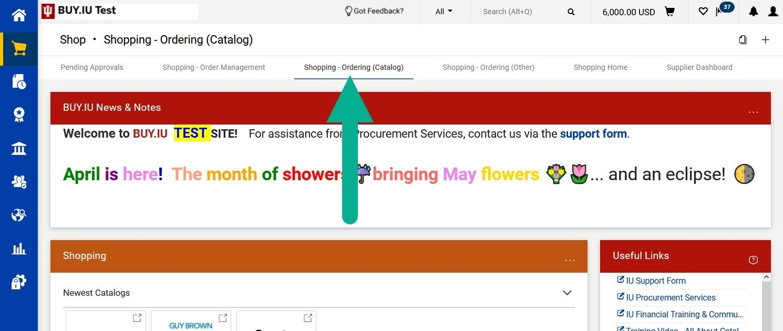

Scroll to the bottom of the dashboard and locate the Maintenance, Repairs, or Operations showcase and click the Blackhawk Network Gift Cards sticker.

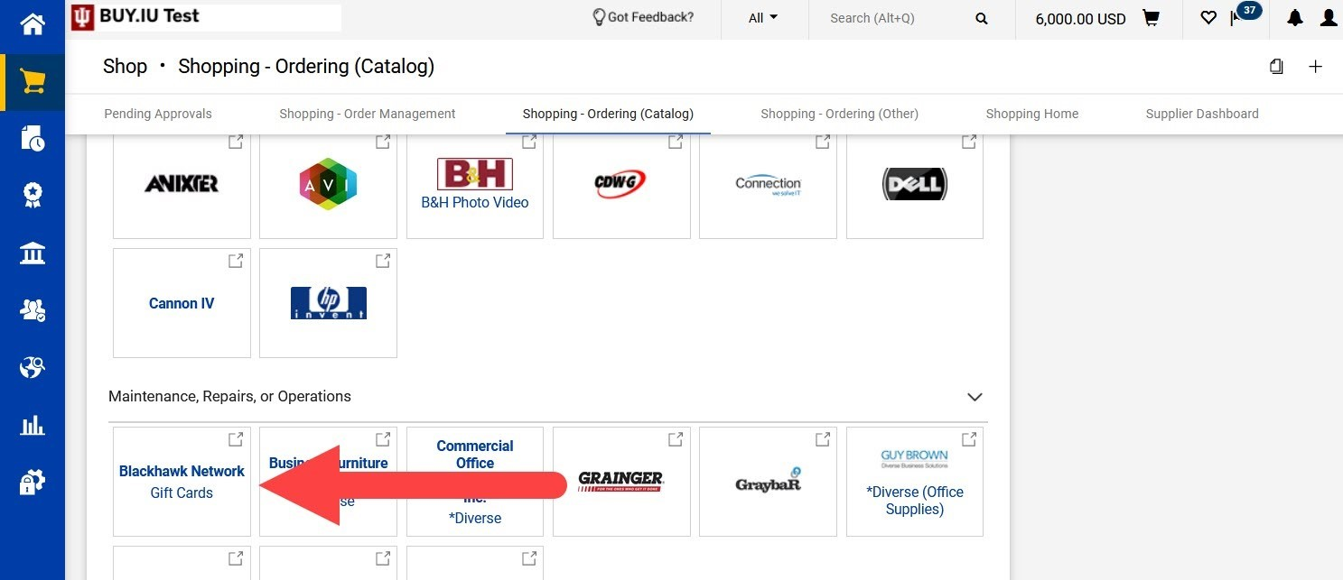

The catalog site opens. First, select the type of gift card you want to purchase.

* Open Loop: Visa gift cards that can be used anywhere Visa is accepted.
* Closed Loop: Cards for use at specific merchants such as Amazon or Target.

Make your selection from the drop-down menu and click Submit.

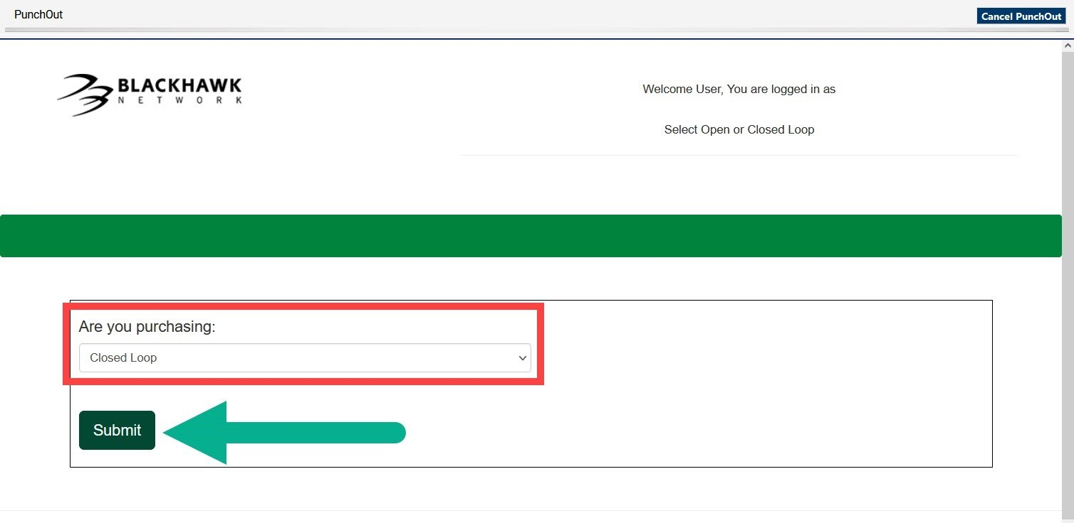

Next, select the gift card format.

* Plastic: Physical cards that are mailed or handed to the recipient directly.
* Digital: Electronic codes that are sent via email or printed off a website.

If you need to purchase physical and digital gift cards, you will need to place an order for each card type. It is not possible to combine plastic and digital cards in one order.

Make your selection and click Submit.

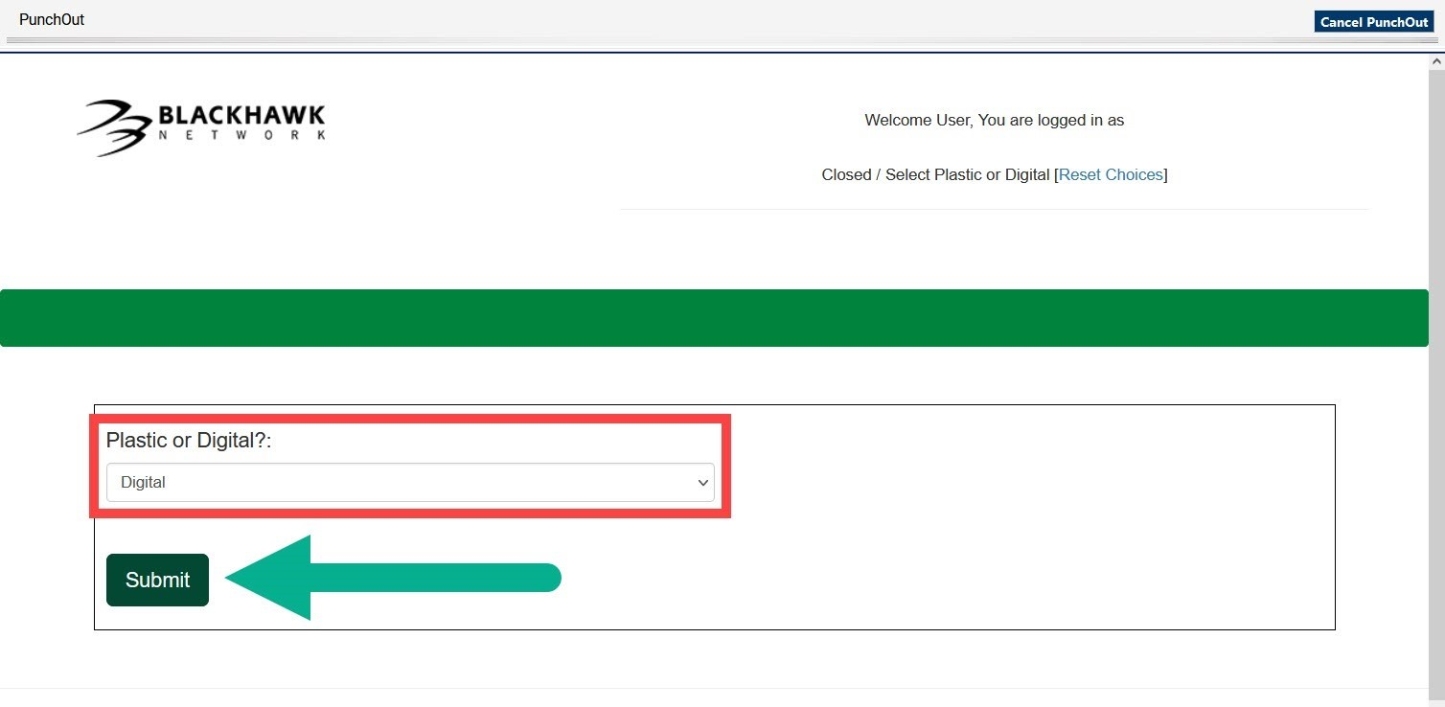

Now you can search for the gift cards you need to purchase.

1. Enter the name of the merchant you’re looking for in the Search Our Catalog field.
2. Click Digital or Plastic (whichever option you selected on the previous screen) in the central green menu bar to view an alphabetical list of available merchants.
3. Select Reset Choices to search for a different type of gift card or different delivery method.

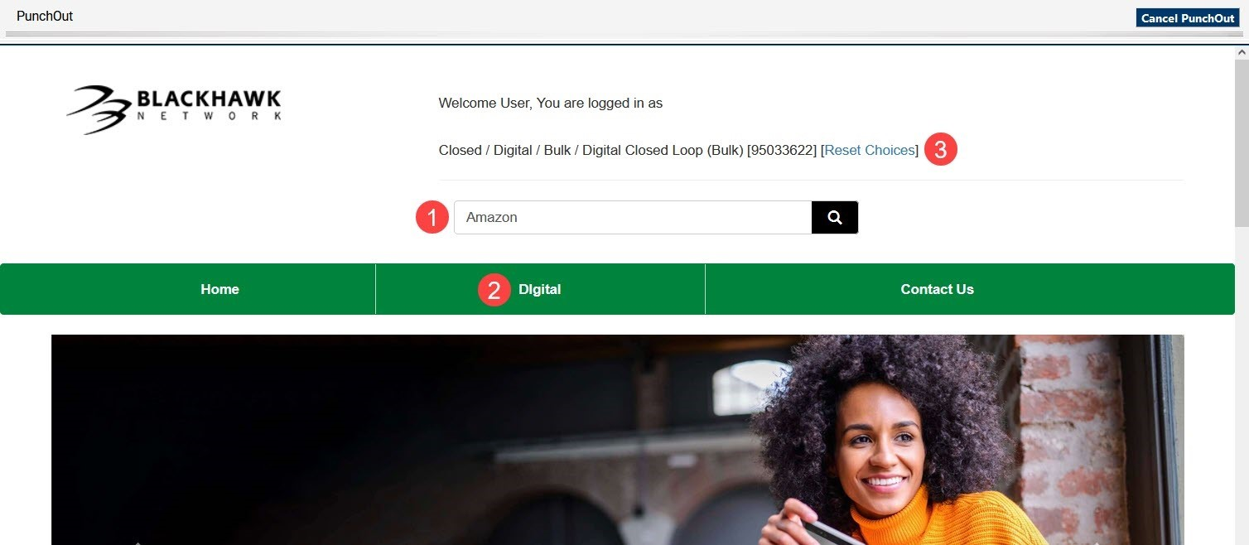

Click Add to Cart under a gift card to add a card in that denomination to your Blackhawk shopping cart.

* + For control group: $150
  + For aphasia group: $250

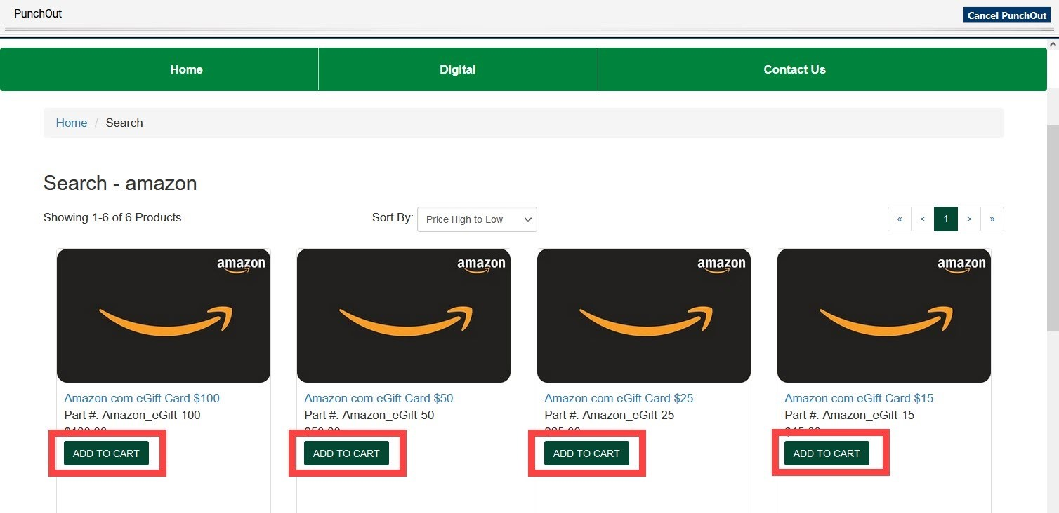

In your Blackhawk cart, update the Quantity field to reflect how many gift cards you need to purchase. Click Update Cart to apply your changes.

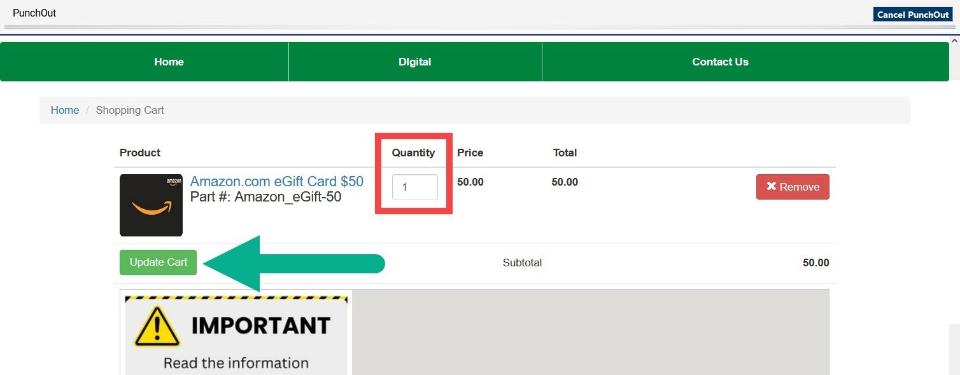

* Enter the number of cards you will need under the dollar correct amount
  + For control group: $150
  + For aphasia group: $250
* After entering the quantity, hit the ENTER key
* Under the checkout box, enter your first name, last name, and email address
* Check the box at the bottom of the page and select Finish Cart (Checkout)
* Then hit the final Checkout button once you have reconfirmed information is correct

Next, you will need to Assign the Cart to our accountant, Kerri Powell.

1. In the top right corner, select **Assign Cart**
2. Search for Kerri Powell and assign her to the cart
3. She will finish the process, and you will receive an email from Blackhawk with instructions to access the gift card

## **Retrieve digital gift card codes**

Digital gift cards must be retrieved online. The purchaser will receive an email from Blackhawk when codes are available.

You will need a Hawk Marketplace User Account to retrieve the codes you purchased. These steps apply to all digital gift cards.

Follow these instructions to create an account and retrieve the codes you purchased.

1. Create a Hawk Marketplace User Account.
   1. You will be sent a registration email when you place your first virtual order.
   2. Choose a password. Passwords cannot contain spaces.
   3. Set up a multi factor authentication.
2. You will receive an email when the order is ready to retrieve.
3. Log in to <https://hawkmarketplace.com/login>
4. Click on Order History in the left-hand navigation.
5. Select order number and click on Item Details.
6. Click Details in black navigation bar and click Download to download a zip file. You will be emailed a security code to gain access to the zip file.
7. Open the zip file and enter the security code, then download the gift card codes.
8. You, as the purchaser, are responsible for securely distributing gift card codes to recipients.

# Automatic Speech Recognition Software Installation and Usage

Talkbank Batchalign2 website homepage: <https://github.com/talkbank/batchalign2?tab=readme-ov-file>

Instructions adapted from: <https://talkbank.org/info/Batchalign2.pdf>

1. Download Python version 3.11. This is the software used to get the Batchalign program, however, the transcription process will be done using Command Prompt.
   1. Python download link for Mac: <https://www.python.org/ftp/python/3.11.7/python-3.11.7-macos11.pkg>
   2. Python download link for Windows: <https://www.python.org/ftp/python/3.11.7/python-3.11.7-amd64.exe>
2. Open Command Prompt by searching in your computer's Start menu.
3. To install the Batchalign program, use the command “**py -m pip install batchalign**.” The screen should look like this:

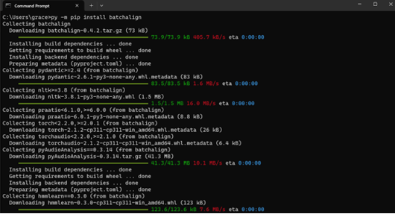

If you see the following error warning, follow the steps below to add the Path to your Scripts folder:

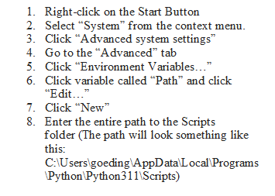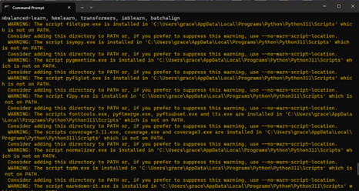

1. Now rerun the original command to install Batchalign: **py -m pip install batchalign**
2. To create your input and output folders: run the following commands in order:
   1. **mkdir ba_data** (You can replace ‘ba_data’ with whatever you would like to call your data folder)
   2. **cd ba_data** (This brings you inside your data folder so you can create your input and output locations)
   3. **mkdir input**
   4. **mkdir output**
3. Now Batchalign is installed! Keep in mind the program can only use .wav files. If you record with iPhone, the format is m4a. Since batchalign only accepts mp3, mp4, and wav, you need to convert m4a to .wav. You can do this using an online converter site such as this one: <https://cloudconvert.com/m4a-to-wav>.
4. Select the file you want to transcribe and put it in your input folder (Users à Your Name à ba_data à input)
5. You are now ready to run the Batchalign command (this will be used each time you want to transcribe a new file:

**batchalign transcribe [your input directory] [your output directory]**

So, for example:

**batchalign transcribe .\ba_data\input .\ba_data\output**

1. When you run your first Batchalign command, you will be asked if you would like to set up Rev.ai now. This is the software that provides the automatic transcription. Rev-AI provides you with 6 free hours for your new account. After that, charges are $.02/minute of audio. Contact Dr. Stark about payment for transcription. To make an account and obtain a rev.ai key, follow the steps below:
   1. Go to [https://rev.ai](https://rev.ai/), sign up, and on the left side of your dashboard, you will find a tab called Access Token.
   2. Click generate to generate a new token and copy and paste this code so you can access it later.
   3. When signing up, you can configure your profile to have no data saved on their servers.
   4. Once you have provided your rev-ai key, it is saved in a file, and you will not need to provide it again.
2. 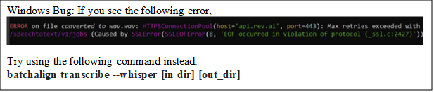If everything goes right, the program will run through the auto transcription and provide you with the .cha file in your output folder! Before running the next file, make sure you empty both the input and output folders.

Using Video Proc Converter

Each subject data folder will also need a “**Compressed Video Files**” folder to store the compressed .mp4 files. These files will be the ones ran through the ASR software. Keep in mind that you will need a full license to the software which will require purchasing (likely) a lifetime license. Please see Dr. Stark about payment options.

Note: Aphasic participants will have Day1_pm and Day2_pm sessions transcribed. Control participants will have cut video (containing ‘conversation’ gem onwards) transcribed.

1. Load video files for day1_pm and day2_pm using the Videobutton. For controls you will upload the cut day1 and day2 files.
2. Select the Codec Option button and set the format settings as shown below:

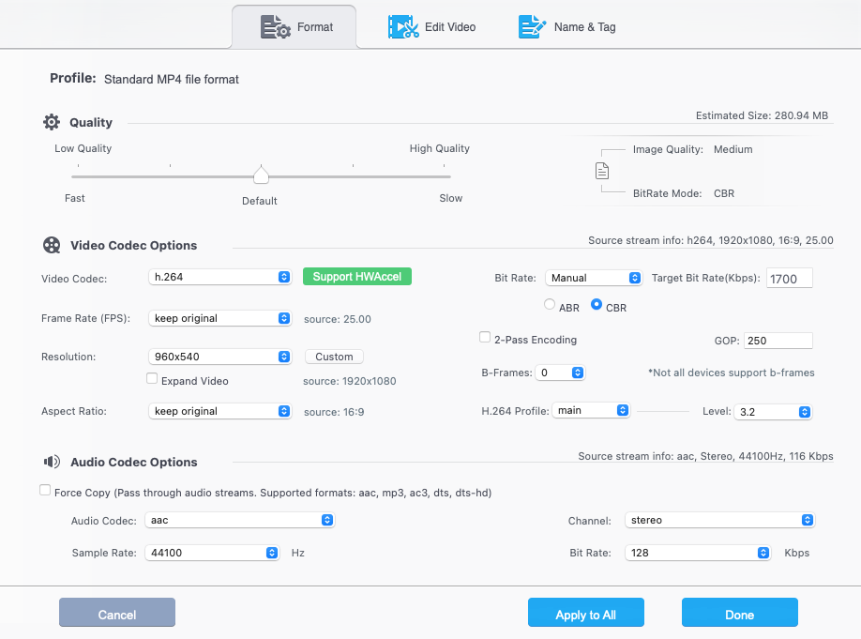

1. Select Apply to All if you are running multiple subjects at one time.
2. Set the output folder to the subject’s “compressed video files” and run the program.
3. You can cut/crop videos at the same time as compressing them

IMPORTANT: due to various factors with Zoom recording, it appears that recordings can be compressed at a certain rate such that they are rather small. In general, try to aim to have videos less than 1 GB. Size is the most important feature of videos. If necessary, you can resize the video (via Video Proc) but make sure to match the bit rate of the original video. Double check that the compressed/cut video is still synced. Unfortunately, depending on the rate that the video was recorded it may require some experimentation with the settings in VideoProc.

# Compiling Data For CMU

Data that is compressed, transcribed, and checked is organized in the **Compiled Data Folder** located in the **Subject Data** Folder. Each subject’s folder will contain the video files, compressed (if needed) and cut for control subjects. Additionally, checked transcripts. The included checked transcripts are the transcripts that undergo the secondary check with the team.

# **Resources**

## ***Ideal Environment Checklist***

Internet connection

1. Ethernet connection (preferred) or reliable Wi-Fi. If possible, confirm the reliability of your Internet by determining bandwidth and speed Hardware
2. Screen sharing device (i.e., computer, iPad) with an adequate display resolution (roughly 9 in. of screen) is required
3. Built-in or external webcam/camera device
4. Functioning audio system is required (i.e., microphone, speaker)
5. Headphones for investigator and participant are recommended
6. Recommended that device can stand on its own (i.e., not required to be handheld)

Environment and experiment setup

1. Image (i.e., camera placement) of participant and investigator should include head and shoulders in the center of the screen
2. If necessary, the camera angle should be adjusted to include participant gesticulation
3. Lighting should be adequate for clear visibility (i.e., facial features, object manipulation)
4. Make sure camera is able to see full upper body including any space where gesturing may occur.

To prevent potential distractions from the experimental environment:

1. Close household windows to reduce background noise
2. Notify other people that you are in a session
3. Remove pets from the room (if possible)
4. Turn phone and other devices to silent or off
5. Close door(s) to room (if possible)
6. Close all unnecessary programs and windows on computer

## ***Teleassessment Guidelines (AphasiaBank)***

*via* MacWhinney, B., Fromm, D., Forbes, M. & Holland, A. (2011). AphasiaBank: Methods for studying discourse. *Aphasiology, 25*,1286-1307.

General tips:

* Allow ample time for as full a response as each participant can provide using this protocol script.
* To facilitate transcription, the examiner's speech, including verbal encouragers, should be kept to a minimum. Use nonverbal encouragers (e.g., head nods, facial expressions, eye contact) instead of verbal encouragers (e.g., “I see”, “mhm”, “yeah”) whenever possible.

Exceptional scenarios

* For those unable to respond to any of the prompts for the Stroke Story, skip the Important Event task and proceed to the first Picture Description (Broken Window).
* If the participant responds to the Broken Window picture description prompt, continue with the protocol, changing the order if that helps, and returning to the initial questions if appropriate.
* If the participant does not respond to the Broken Window picture, and you believe these tasks are too difficult, you can discontinue as you see fit.

**Best protocol study:**

[**https://pubmed.ncbi.nlm.nih.gov/34019776/**](https://pubmed.ncbi.nlm.nih.gov/34019776/)

**AphasiaBank Teletesting Protocol:**

<https://aphasia.talkbank.org/protocol/english/>

**Recruitment methods:**

From Doub, Hittson & Stark 2021

Set up both appointments simultaneously

Include instructions for downloading Zoom in preliminary emails

Go through environment checklist together at the beginning of the session

**Video Interview Protocol:**

From Stark, Clough & Duff, 2021:

Make sure camera is positioned correctly so the following parameters are met:

For autobiographical info: Particpants can retell the same story as last week or tell a new story, make sure to include whatever comes to the top of their head or whatever is most readily available.

**New tasks:**

1. Narrative 2:
   1. From: Kurczek, J., Wechsler, E., Ahuja, S., Jensen, U., Cohen, N. J., Tranel, D., & Duff, M. (2015). Differential contributions of hippocampus and medial prefrontal cortex to self-projection and self-referential processing. Neuropsychologia, 73, 116–126.
      1. Participants were given a neutral cue word and asked to (re)construct events across four time conditions: real past, imagined past, imagined present, and future. These event narratives were analyzed for the number of internal and external details to quantify the extent of episodic (re)experiencing.
      2. For our study, we could provide a word and only ask participants to reconstruct an event across **one** time condition, maybe provide information about a personal life event?
      3. Neutral cue words were selected from the Affective Norms for Emotional Words database
         1. Specifically used: clock, bird, hotel, restaurant
2. Procedural 2 and 3:
   1. From: Ulatowska, H. K., Doyel, A. W., Stern, R. F., Haynes, S. M., & North, A. J. (1983). *Production of procedural discourse in aphasia. Brain and Language, 18(2), 315–341.*
      1. Changing a light bulb in a ceiling fixture, making a favorite sandwich, making scrambled eggs, and instructing a person from another country on how to shop in an American supermarket.
      2. Subjects to assume listener does not know how to do these tasks
      3. Varying levels of difficulty of task
      4. Several steps, not food related
      5. Test and Retest: Sandwich and laundry
      6. Test: Getting dressed in the morning (weekend in the summer)
      7. Retest: How to grow a flower outside

**Co-speech gesture coding manual**

For coding gestures in the NEURAL Research Lab please see the separate coding manual.