Philadelphia Sentence Comprehension

Instructions

For each item, show the participant the picture pair and say the target sentence. Instruct the participant to point to the picture that goes with the sentence. Indicate correct and incorrect responses in the corresponding spaces on the score sheet. If the participant requests that you repeat the sentence, or does not respond within 10 seconds, repeat the sentence once and note this on the score sheet by adding an “R” next to the number of the repeated item on the score sheet.

Instructions to Participant (given while showing the 2 examples below)

“Now I’m going to show you some pictures, and then I’ll say a sentence. Listen carefully, and then point to the picture that goes with the sentence. “

Example 1
“For example, look at these two pictures. Here’s the sentence, ‘The dog chases the rabbit.’ Which picture matches that sentence?"
Give the participant a chance to respond, repeating the sentence if needed.
If the participant answers correctly: “That’s it, the dog chases the rabbit.“
If the participant answers incorrectly or does not respond: “This is the correct picture, right? The dog chases the rabbit.”

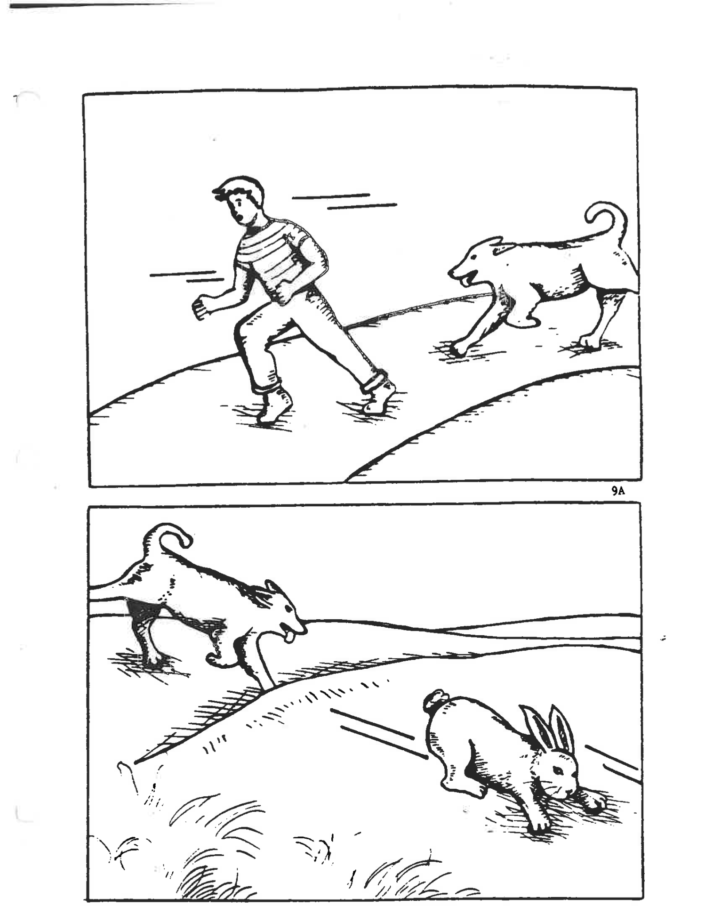
Example 2
“Let’s try another one. Take a look at these pictures. Here’s the sentence, ‘The airplane is in the hangar’. Which picture matches that sentence?"
If the participant answers correctly: “That’s it, the airplane is in the hangar.“
If the participant answers incorrectly or does not respond: “This is the correct picture, right? The airplane is in the hangar.”

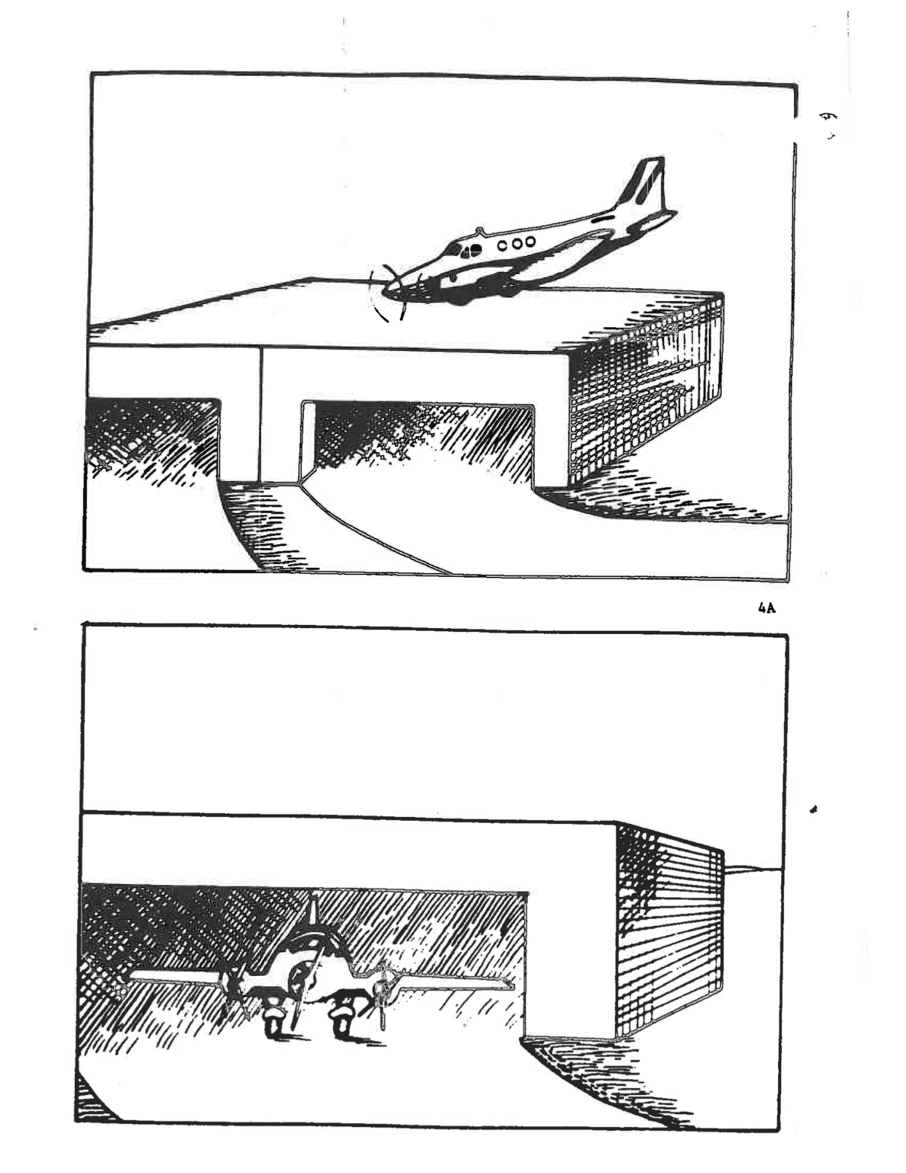
Provide further explanation and demonstration as needed before starting the test.
Sentence Comprehension Response Form (Adapted from Philadelphia Comprehension Battery, Saffran et al., 1988)
ID: _______________________________________ Date: _______________________
# | Sentence | ORC-L | SRC-L | LOC-L | ACT-L | PAS-L | ORC-R | SRC-R | LOC-R | ACT-R | PAS-R
1 | The woman that the man painted was friendly. (T)
2 | The robber that the policeman shot was wounded. (T)
3 | The dog that chased the boy was fast. (T)
4 | The hook is under the bookshelf. (T)
5 | The policeman shoots the robber. (T)
6 | The man serves the woman. (B)
7 | The woman that photographed the man was friendly. (B)
8 | The dog is washed by the boy. (B)
9 | The policeman that the robber shot was ruthless. (T)
10 | The hunter follows the dog. (T)
11 | The man is served by the woman. (T)
12 | The dog is followed by the hunter. (T)
13 | The boy that the dog chased was lost. (B)
14 | The boy is under the wagon. (B)
15 | The newspaper is on the book. (B)
16 | The girl that the boy washed was dirty. (B)
17 | The baby follows the dog. (B)
18 | The robber is shot by the policeman. (B)
19 | The girl is under the tree. (T)
20 | The girl that washed the boy was talkative. (B)
 | Total | / 2 | / 2 | / 2 | / 2 | / 2 | / 2 | / 2 | / 2 | / 2 | / 2
ORC = Object relative clause SRC = Subject relative clause Lexical (L) total: / 10 Reversible (R) total: / 10
LOC = Locative ACT = Active PAS = Passive Overall (L+R) total: / 20
Temple University Language and STM Battery (Martin et al., 2007)

